Harris Sports Chiropractic & Wellness Center

Date: _____ / _____ / _____

Name: ______________________________________________________________________________

SS#: ______________________________ DOB: _____ / _____ / _____ Age: _______

Male Female

Address: ____________________________________________________________________________

City, State, Zip: _____________________________________________________________________

Cell Phone: ______________________ Work Phone: _____________________________________

Home Phone: _______________________________________________________________________

Email Address: ______________________________________________________________________

Spouse’s Name: _____________________________________________________________________

Do you have children? Yes ___ No ___ If yes, how many? ________

Have you seen a chiropractor before? Yes ___ No ___
Clinic/Doctor’s Name:

Emergency Contact

Name: ______________________________________________Relation: _______________________

Phone: ____________________________

Primary Insurance

Insurance Co.: ______________________________________________________________________

Group #: ________________________________________

Subscriber ID: ___________________________________

Insured’s Name: ____________________________________________________________________

Insured’s Employer: _________________________________________________________________

Insured’s SS#: ____________________________________

Relation: __________________ DOB: ________________

Secondary Insurance

Insurance Co.: ______________________________________________________________________

Group #: ________________________________________

Subscriber ID: ___________________________________

Insured’s Name: ____________________________________________________________________

Insured’s Employer: _________________________________________________________________

Insured’s SS#: ____________________________________

Relation: __________________ DOB: ________________

Person ultimately responsible for account (if same as patient, please leave blank)
Name: _____________________________________ Relation: ______________________
DOB: __________________
Billing Address:____________________________________________________________________________
Driver’s License #: ____________________________ Phone: _____________________________

Medical History
Reason for today’s visit: _____ Emergency _____ New injury _____ Old injury _____

Chronic pain ____ Wellness ____

Are you in pain? __________

Rate your pain with the following scale: discomfort 1 2 3 4 5 6 7 8 9 10 intense

Major Complaint: ____________________________________________________________________________________________________________________________________________________________________________________________________________________________________________________________________________________________________________________________________________________

Where did your injury occur? _____ Work _____ Sports/Play _____ Auto Accident ____

Routine/Household Activity _____

When did your condition/accident occur? ____________________________________________

Please explain what happened: _____________________________________________________________________________________

Is condition interfering with: _____ Work _____ Sleep or _____ Daily routine?
If so, how: __________________________________________________________________________

Has this or something similar happened in the past? Yes No

If Yes, explain: ______________________________________________________________________

Are you taking any of the following medications?

Painkiller (i.e. Aspirin) Muscle Relaxers

Blood thinners Tranquilizers Insulin Other: _____________

List any serious accidents with dates: ____________________________________________________________________
Family health history: ________________________________________________________________________________
Take supplements/vitamins? No Yes
Do you exercise? No Yes If yes, how often? _____________________
Do you smoke? No Yes How often? ____________ For how long? ____________
Do you drink alcohol? No Yes If so, how many drinks per week? ____________
Are you dieting? No Yes Since: _______________

For women only: Are you on birth control? No Yes Are you nursing? No Yes
Are you pregnant? No Yes If so, how many weeks? ________________

Using the body chart below, please circle all affected areas.

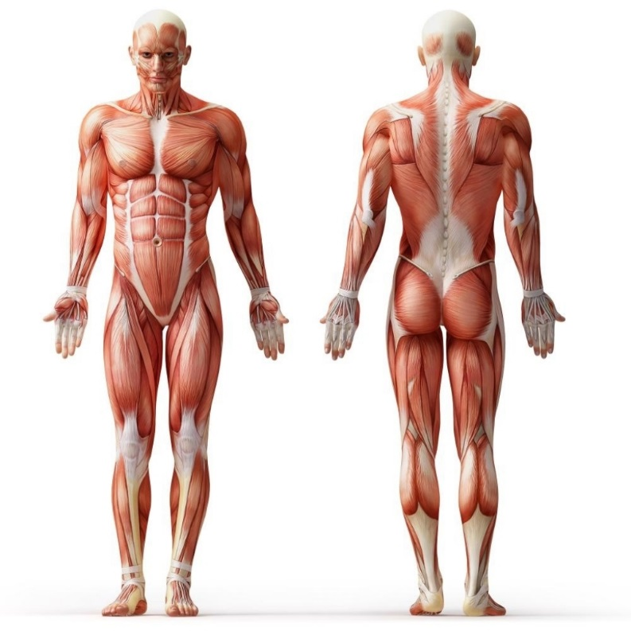

Please circle yes (Y) or no (N) on the following:

Y N Difficulty Breathing
Y N Cancer
Y N Chemotherapy
Y N Lower Back Pain
Y N Heart Murmur
Y N Kidney Problems
Y N Shingles
Y N High/Low Blood Pressure
Y N Venereal Disease
Y N Artificial Bones/Joints
Y N HIV/AIDS/ARC
Y N Tuberculosis
Y N Congenital Heart Defect
Y N Emphysema/Asthma
Y N Alcohol/Drug Abuse
Y N Arthritis
Y N Heart Attack/Stroke
Y N Artificial Valves
Y N Frequent Neck Pain
Y N Glaucoma
Y N Fainting/Seizures/Epilepsy
Y N Severe/Frequent Headaches
Y N Anemia/Diabetes
Y N Ulcers/Colitis
Y N Psychiatric Problems
Y N Rheumatic Fever
Y N Mitral Valve Prolapse
Y N Sinus Problems
Y N Heart Surgery/Pacemaker
Y N Hepatitis

Please list any surgeries with dates and/or any other serious medical condition(s) not listed above: _____________________________________________________________________________________

Bottom of Form
HIPAA Notice of Privacy Practices
THIS NOTICE DESCRIBES HOW MEDICAL INFORMATION ABOUT YOU MAY BE USED AND DISCLOSED AND HOW YOU CAN GET ACCESS TO THIS INFORMATION. PLEASE REVIEW IT CAREFULLY.
This notice of Privacy Practices describes how we may use and disclose your protected health information (PHI) to carry out treatment, payment, or health care operations (TPO) and for other purposes that are permitted or required by law. It also describes your rights to access and control your protected health information. “Protected health information” is information about you, including demographic information, that may identify you and that relates to your past, present, or future physical or mental health or condition and related health care services.
1. Uses and Disclosures of Protected Health Information
Your protected health information may be used and disclosed by your physician, our office staff, and others outside of our office that are involved in your care and treatment for the purpose of providing health care services to you, to pay your health care bills, to support the operation of the physician’s practice, and any other use required by law.
Treatment: We will use and disclose your protected health information to provide, coordinate, or manage your health care and any related services. This includes the coordination or management of your health care with a third party. For example, we would disclose your protected health information, as necessary to a home health agency that provides care to you. For example, your protected health information may be provided to a physician to whom you have been referred to ensure that the physician has the necessary information to diagnose or treat you.
Payment: Your protected health information will be used, as needed, to obtain payment for your health care services. For example, obtaining approval for a hospital stay may require that your relevant protected health information be disclosed to the health plan to obtain approval for the hospital admission.
Healthcare Operations: We may use or disclose, as needed, your protected health information in order to support the business activities of your physician’s practice. These activities include, but are not limited to, quality assessment activities, employee review activities, training of medical students, licensing, and conducting or arranging for other business activities. For example, we may disclose your protected health information to medical school students that see patients at our office. In addition, we may use a sign-in sheet at the registration desk where you will be asked to sign your name and indicate your physician. We may also call you by name in the waiting room when your physician is ready to see you. We may use or disclose your protected health information, as necessary, to contact you to remind you of your appointment.
We may use or disclose your protected health information in the following situations without your authorization. These situations include: as required by law, public health issues as required by law, communicable diseases, health oversight, abuse or neglect, food and drug administration requirements, legal proceedings, law enforcement, coroners, funeral inmates, and required uses and disclosures. Under the law, we must make disclosures to you and when required by the Secretary of the Department of Health and Human Services to investigate or determine our compliance with the requirements of Section 165.500.
Other permitted and required uses and disclosures will be made only with your consent, authorization, or opportunity to object unless required by law. You may revoke this authorization at any time, in writing, except to the extent that your physician or the physician’s practice has taken an action in reliance on the use or disclosure indicated in the authorization.

Signature on the following page is only acknowledgement that you have received this Notice of Privacy Practices

Signature: _______________________________________________________________________ Date: ____________________________

Signature on File

I, _________________________________________________ (Name of Patient / Parent or Guardian if a minor)
and or _____________________________________________________ (Name of Insured)

Hereby authorize the Harris Sports Chiropractic & Wellness Center to affix my name to any and all claims or documents as related to any and all health benefits due me and my dependents.
I hereby authorize payment of chiropractic benefits otherwise payable to me, directly to the office listed above. I have reviewed the treatment plan and fees. I agree to be responsible for all charges for chiropractic services and materials not paid by my chiropractic benefit plan, unless the treating physician or chiropractic practice has a contractual agreement with my plan prohibiting all or a portion of such charges. To the extent permitted under applicable law, I authorize release of any information relating to the claim.
This "Authorization" will be valid from this date. A photocopy of this document may act as an original.
*Please understand that we are billing your insurance company as a courtesy to you, our patient. If your insurance company does not pay the claims in full you will be responsible for any and all balances remaining. As a courtesy to you we will bill the insurance company and provide all necessary documentation to help expedite your claims, after 90 days if the claims have not been paid we will provide you this information and require payment in full by you.
By initialing here ________________________________ you accept all responsibility for any unpaid balances.

Signature: _______________________________________________ Date: _____/_____/_____

